TOEFL Weekend Group ClassSometimes we are tested. Not to show our
weakness, but to show our strengths!

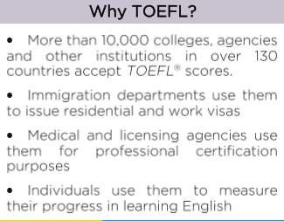
Penang

Enroll Now
04 2104 332
04 2104 334
Info.tprpg@sarabeattie.com www.facebook.com/TPReviewPng www.princetonreviewpg.com Theprincetonreviewpenang
Suite E&F 18 Floor, Gurney Tower, Persiaran Gurney 10250 Penang.

Sara Beattie MDC Sdn Bhd.

DATE | CLASS | TIME
 | 10 Jan 2020 TEST 1
11 Jan 2020  (Sat) | Class 1 | 10pm – 12pm
12 Jan 2020  (Sun) | Class 2 | 10pm – 12pm
18 Jan 2020  (Sat) | Class 3 | 10pm – 12pm
19 Jan 2020  (Sun) | Class 4 | 10pm – 12pm
25 Jan 2019  (Sat) | Class 5 | 10pm – 12pm
26 Jan 2020  (Sun) | Class 6 | 10pm – 12pm
1 Feb 2020  (Sat) | Class 7 | 10pm – 12pm
2 Feb 2020  (Sun) | Class 8 | 10pm – 12pm
8 Feb 2020  (Sat) | Class 9 | 10pm – 12pm
 | 9 Feb 2020 TEST 2
15 Feb 2020  (Sat) | Class 10 | 10pm – 12pm

Course Structure:
TOEFL 9A14
*subject to change
20 Class Hours

Princeton Review Materials:
Exclusive Princeton Review Materials
Additional Handouts
Reading
Speaking
Listening
Writing

**Additional homework will be given for outside classroom activities

